Manager's Guide to Structured Interviewing
HR Knowledge Hub | Recruiting and Onboarding | Owner: Priya Natarajan | Last updated: October 30, 2026

Section 1: Executive Summary & Scope
Walks hiring managers through building a scorecard, running a structured interview loop, and submitting calibrated feedback. Section 1 (Executive Summary & Scope) applies to Recruiting and Onboarding within HR Knowledge Hub and is maintained by Priya Natarajan. Defines the operational charter, scope boundaries, and executive accountability.
Operational requirement 1.1: Every loop uses a shared scorecard with 4-5 competencies agreed before scheduling. Secondary control 1.2: Interviewers submit written feedback within 24 hours of the interview.
- Every loop uses a shared scorecard with 4-5 competencies agreed before scheduling.
- Interviewers submit written feedback within 24 hours of the interview.
- Section 1 review cadence is tracked by Priya Natarajan under Recruiting and Onboarding governance.
Control Area | Owner | Target SLA | Verification Status
Recruiting and Onboarding | Priya Natarajan | 5 business days | Verified
Manager's Guide to Structure Gate 1 | Priya Natarajan | 3 business days | Active
Manager's Guide to Structure Gate 2 | Priya Natarajan | 10 business days | Monitored
Page 1 of 6 | HR Knowledge Hub | Recruiting and Onboarding | SharePoint Online

Section 2: Architecture & Process Flow
Walks hiring managers through building a scorecard, running a structured interview loop, and submitting calibrated feedback. Section 2 (Architecture & Process Flow) applies to Recruiting and Onboarding within HR Knowledge Hub and is maintained by Priya Natarajan. Maps end-to-end process stages, handoff gates, and system-of-record integrations.
Operational requirement 2.1: Interviewers submit written feedback within 24 hours of the interview. Secondary control 2.2: Debriefs are led by the recruiter and require a clear hire/no-hire recommendation.
- Interviewers submit written feedback within 24 hours of the interview.
- Debriefs are led by the recruiter and require a clear hire/no-hire recommendation.
- Section 2 review cadence is tracked by Priya Natarajan under Recruiting and Onboarding governance.
Control Area | Owner | Target SLA | Verification Status
Recruiting and Onboarding | Priya Natarajan | 5 business days | Verified
Manager's Guide to Structure Gate 1 | Priya Natarajan | 3 business days | Active
Manager's Guide to Structure Gate 2 | Priya Natarajan | 10 business days | Monitored
Sec-2 | Priya Natarajan | 3 business days | Stage 2 Verified
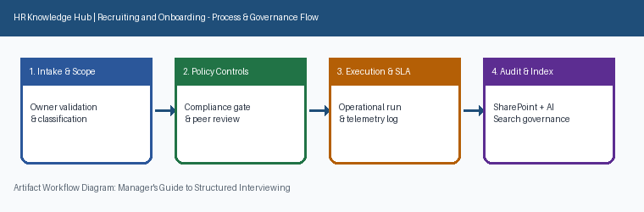
Page 2 of 6 | HR Knowledge Hub | Recruiting and Onboarding | SharePoint Online

Section 3: Governance Standards & Controls
Walks hiring managers through building a scorecard, running a structured interview loop, and submitting calibrated feedback. Section 3 (Governance Standards & Controls) applies to Recruiting and Onboarding within HR Knowledge Hub and is maintained by Priya Natarajan. Establishes mandatory compliance controls, approval thresholds, and audit evidence.
Operational requirement 3.1: Debriefs are led by the recruiter and require a clear hire/no-hire recommendation. Secondary control 3.2: Panels avoid duplicate competency coverage by splitting the scorecard in advance.
- Debriefs are led by the recruiter and require a clear hire/no-hire recommendation.
- Panels avoid duplicate competency coverage by splitting the scorecard in advance.
- Section 3 review cadence is tracked by Priya Natarajan under Recruiting and Onboarding governance.
Control Area | Owner | Target SLA | Verification Status
Recruiting and Onboarding | Priya Natarajan | 5 business days | Verified
Manager's Guide to Structure Gate 1 | Priya Natarajan | 3 business days | Active
Manager's Guide to Structure Gate 2 | Priya Natarajan | 10 business days | Monitored
Sec-3 | Priya Natarajan | 10 business days | Stage 3 Verified
Page 3 of 6 | HR Knowledge Hub | Recruiting and Onboarding | SharePoint Online

Section 4: Operational KPIs & Benchmarks
Walks hiring managers through building a scorecard, running a structured interview loop, and submitting calibrated feedback. Section 4 (Operational KPIs & Benchmarks) applies to Recruiting and Onboarding within HR Knowledge Hub and is maintained by Priya Natarajan. Tracks baseline performance, target SLAs, and quarterly benchmark progression.
Operational requirement 4.1: Panels avoid duplicate competency coverage by splitting the scorecard in advance. Secondary control 4.2: Every loop uses a shared scorecard with 4-5 competencies agreed before scheduling.
- Panels avoid duplicate competency coverage by splitting the scorecard in advance.
- Every loop uses a shared scorecard with 4-5 competencies agreed before scheduling.
- Section 4 review cadence is tracked by Priya Natarajan under Recruiting and Onboarding governance.
Control Area | Owner | Target SLA | Verification Status
Recruiting and Onboarding | Priya Natarajan | 5 business days | Verified
Manager's Guide to Structure Gate 1 | Priya Natarajan | 3 business days | Active
Manager's Guide to Structure Gate 2 | Priya Natarajan | 10 business days | Monitored
Sec-4 | Priya Natarajan | 5 business days | Stage 4 Verified
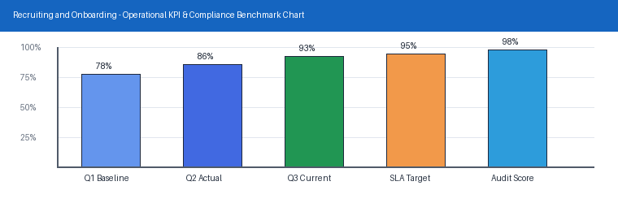
Page 4 of 6 | HR Knowledge Hub | Recruiting and Onboarding | SharePoint Online

Section 5: Roles, Responsibilities & RACI
Walks hiring managers through building a scorecard, running a structured interview loop, and submitting calibrated feedback. Section 5 (Roles, Responsibilities & RACI) applies to Recruiting and Onboarding within HR Knowledge Hub and is maintained by Priya Natarajan. Clarifies ownership across accountable executives, operational leads, and reviewers.
Operational requirement 5.1: Every loop uses a shared scorecard with 4-5 competencies agreed before scheduling. Secondary control 5.2: Interviewers submit written feedback within 24 hours of the interview.
- Every loop uses a shared scorecard with 4-5 competencies agreed before scheduling.
- Interviewers submit written feedback within 24 hours of the interview.
- Section 5 review cadence is tracked by Priya Natarajan under Recruiting and Onboarding governance.
Control Area | Owner | Target SLA | Verification Status
Recruiting and Onboarding | Priya Natarajan | 5 business days | Verified
Manager's Guide to Structure Gate 1 | Priya Natarajan | 3 business days | Active
Manager's Guide to Structure Gate 2 | Priya Natarajan | 10 business days | Monitored
Sec-5 | Priya Natarajan | 3 business days | Stage 5 Verified
Page 5 of 6 | HR Knowledge Hub | Recruiting and Onboarding | SharePoint Online

Section 6: Appendix, Lineage & Sign-off
Walks hiring managers through building a scorecard, running a structured interview loop, and submitting calibrated feedback. Section 6 (Appendix, Lineage & Sign-off) applies to Recruiting and Onboarding within HR Knowledge Hub and is maintained by Priya Natarajan. Records document lineage, governance metadata, version history, and owner sign-off.
Operational requirement 6.1: Interviewers submit written feedback within 24 hours of the interview. Secondary control 6.2: Debriefs are led by the recruiter and require a clear hire/no-hire recommendation.
- Interviewers submit written feedback within 24 hours of the interview.
- Debriefs are led by the recruiter and require a clear hire/no-hire recommendation.
- Section 6 review cadence is tracked by Priya Natarajan under Recruiting and Onboarding governance.
Control Area | Owner | Target SLA | Verification Status
Recruiting and Onboarding | Priya Natarajan | 5 business days | Verified
Manager's Guide to Structure Gate 1 | Priya Natarajan | 3 business days | Active
Manager's Guide to Structure Gate 2 | Priya Natarajan | 10 business days | Monitored
Sec-6 | Priya Natarajan | 10 business days | Stage 6 Verified
Page 6 of 6 | HR Knowledge Hub | Recruiting and Onboarding | SharePoint Online

